EX NO: 1 BUILD A LAN TOPOLOGY IN CISCO PACKET TRACER

OBJECTIVE(i): IMPLEMENTATION OF STAR TOPOLOGY
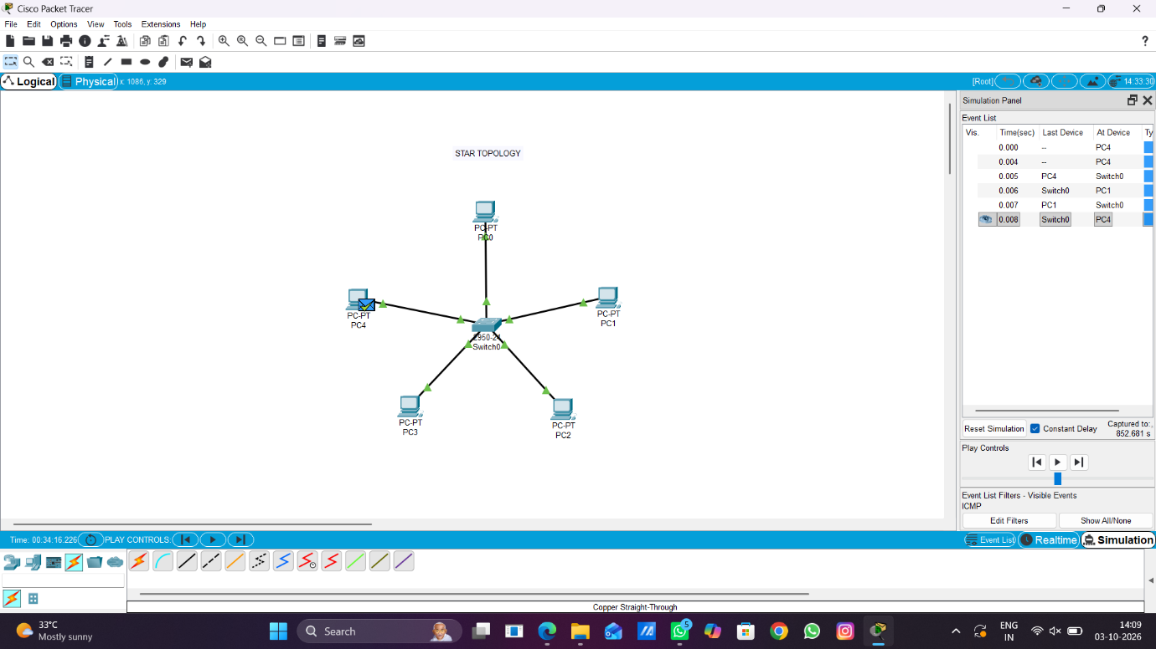

OBJECTIVE(ii): IMPLEMENTATION OF MESH TOPOLOGY
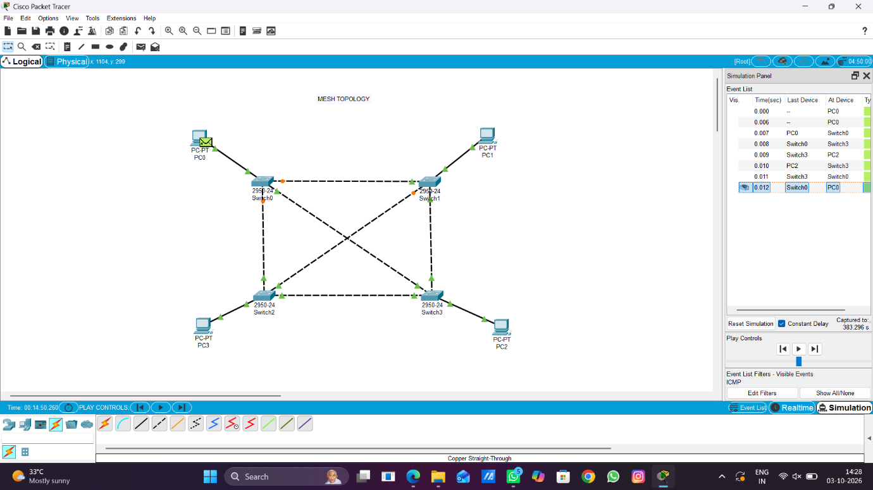

OBJECTIVE(iii): IMPLEMENTATION OF HYBRID TOPOLOGY
